**DAILY ONLINE ACTIVITIES SUMMARY**

|  |  |  |  |  |  |  |  |  |
| --- | --- | --- | --- | --- | --- | --- | --- | --- |
| **Date:** | 26-05-2020 | | | | | **Name:** | K S Prajwal | |
| **Sem & Sec** | Vi A sec | | | | | **USN:** | 4AL18CS032 | |
| **Online Test Summary** | | | | | | | | |
| **Subject** | | Design and analysis of algorithm | | | | | | |
| **Max. Marks** | | 30 | | **Score** | | | 26 | |
| **Certification Course Summary** | | | | | | | | |
| **Course** | Computer Vision Essentials | | | | | | | |
| **Certificate Provider** | | | Greatlearning.in | | **Duration** | | | **1.5 hr** |
| **Coding Challenges** | | | | | | | | |
| **Problem Statement:** 1. Number of permutations of a given string  2. Number of subarrays of the given type | | | | | | | | |
| **Status:** completed | | | | | | | | |
| **Uploaded the report in Github** | | | | | yes | | | |
| **If yes Repository name** | | | | | <https://github.com/alvas-education-foundation/KS_Prajwal> | | | |
| **Uploaded the report in slack** | | | | | yes | | | |

Online Test Details: (Attach the snapshot and briefly write the report for the same)

Certification Course Details: (Attach the snapshot and briefly write the report for the same)

Coding Challenges Details: (Attach the snapshot and briefly write the report for the same)

ONLINE TEST:

The online test was from module 2 which was about divide and conquer algorithms and decrease and conquer algorithms. There were 30 questions and the duration were 45 minutes. The questions were optimal and were easy. The score that I got in the test is 26/30.

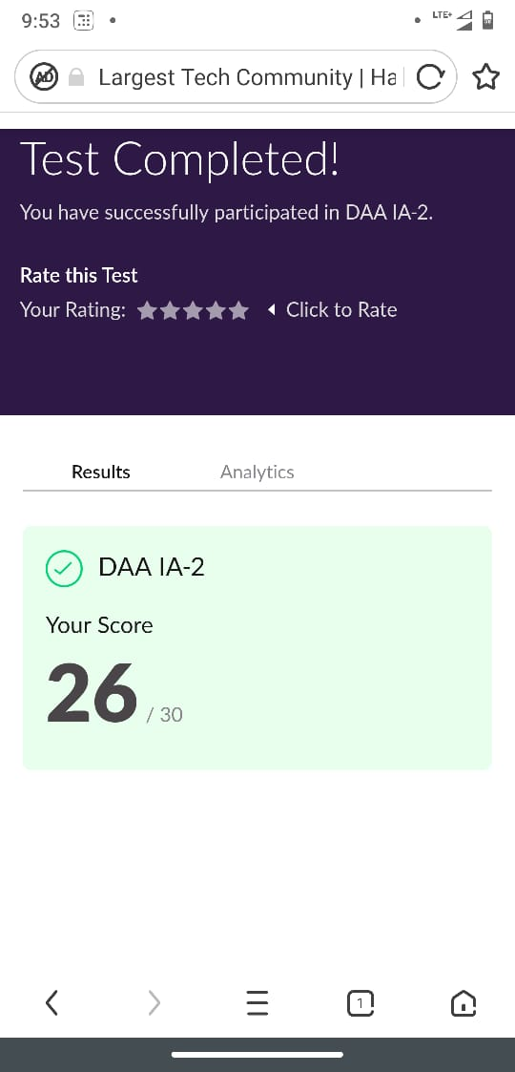

Snapshot of certification course:

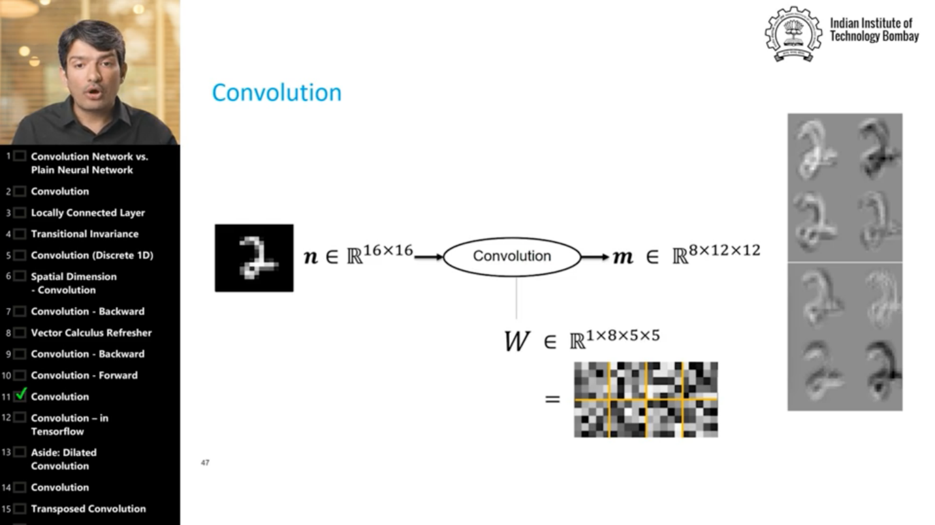

It was about the forward convolution backward convolution how it works, theory behind it

**Online coding:**

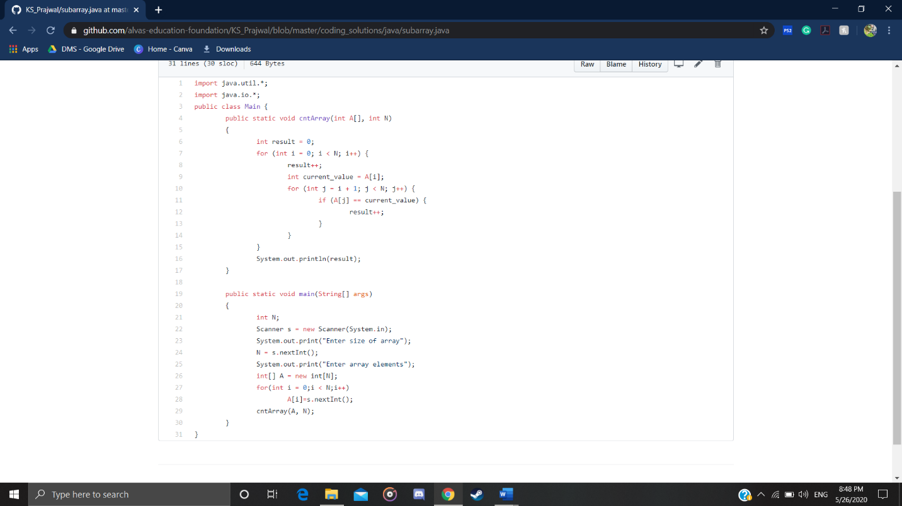Problem 1: (Using JAVA) Given an array A of size N where the array elements contain values from 1 to N with duplicates, the task is to find total number of subarrays which start and end with the same element.

Problem 2: (using C language) Write a program in C to print all permutations of a given string using pointers.

